SMART STREET LIGHT SYSTEM
Harinisubashree S  Computer Science and Engineering  Rajalakshmi Engineering College  Chennai, India  210701072@rajalakshmi.edu.in | Harithaah M S  Computer Science and Engineering  Rajalakshmi Engineering College  Chennai, India  210701079@rajalakshmi.edu.in | Helen Shalini A  Computer Science and Engineering  Rajalakshmi Engineering College  Chennai, India  210701082@rajalakshmi.edu.in

Abstract— Street lighting is an essential component of the infrastructure of cities; it brightens public areas, pedestrian pathways, and streets. But typical street lighting systems frequently display inefficiencies in terms of energy usage and upkeep procedures, requiring for the creation of creative solutions to deal with these issues. Our project aims at enhancing energy efficiency, lighting executives, and maintenance processes in urban contexts through using Internet of Things (IoT) technology in the planning and installation of a Smart Street Light System. Our Smart Street Light System's primary role is to automatically modify brightness in alignment with ambient factors and usage patterns in real time. Each street light fixture has motion sensors and Internet of Things (IoT) devices attached to it so that the system can detect the presence of vehicles or pedestrians and alter brightness levels accordingly. In order to save energy during times when there is low activity, the algorithm dims the brightness; yet, when motion is detected, the brightness increases in order to guarantee adequate light and improve safety on city streets. This adaptive lighting solution reduces energy waste while simultaneously boosting illumination levels and boosting visibility for both cars and pedestrians. Further, in order to minimize downtime and hurry up repair efforts, our system contains proactive defect detection techniques. The system continually monitors each street light's operational status through the combination of sensor-based monitoring and remote interaction, allowing for the real-time detection of any problems or malfunctions. When a problem presents itself, the system sends out alerts or notifications so that maintenance staff may take quick action and fix the situation. Our solution preserves continuous operating of the lighting infrastructure, lowers repair costs, and extends the service life of street light fixtures through the implementation of a proactive maintenance strategy. By doing the combination of Internet of Things (IoT) solutions, our project presents a comprehensive solution to enhance street lighting systems in urban contexts. Future smarter, more sustainable cities will be made attainable by our Smart Street Light System, which enhances maintenance processes, adjusts brightness levels dynamically, and utilizes less energy. All of these benefits mark an important advancement in the control of urban illuminating infrastructure.

I.INTRODUCTION
Urban street lighting is necessary for accessibility and safety, but the present systems sometimes waste energy and need expensive maintenance. Our project uses Internet of Things (IoT) technologies to create a Smart Street Light System to try to address these issues. This system uses real-time usage patterns to automatically alter brightness, saving energy during moments of inactivity and improving visibility when needed. Proactive problem identification processes also cut maintenance expenses and downtime. Our technology strives to build smarter, more sustainable urban settings through minimizing breakdowns, enhancing lighting executives, and lowering energy use. With the goal to maximize street lighting efficiency, a "smart street light system" incorporates wireless connectivity, sensors, and data analytics. This includes remote monitoring and control, predictive maintenance to prevent downtime, energy consumption optimization, and automatic brightness shift based on ambient light and traffic conditions.The objective of the project is to build a smart street light system that employs the Internet of Things and changes brightness in response to presence detection. This involves installing sensors that detect human presence, enabling the system to alter light brightness to increase when presence is sensed and reduce when it is absent. The gadget will additionally have a capacity to report any broken lights, assuring timely maintenance and ongoing operation. The primary goal is to create a street lighting infrastructure that is energy-efficient and responsive, enhancing sustainability and safety in neighborhoods. The objective of the project is to build a smart street light system that employs the Internet of Things and changes brightness in response to presence detection. This involves installing sensors that detect human presence, enabling the system to alter light brightness to increase when presence is sensed and reduce when it is absent. The gadget will additionally have a capacity to report any broken lights, assuring timely maintenance and ongoing operation. The primary goal is to create a street lighting infrastructure that is energy-efficient and responsive, enhancing sustainability and safety in neighborhoods.Urban street lighting is a vital component of city infrastructure, contributing to safety, security, and quality of life. Traditional street lighting systems, which typically operate at a constant brightness level regardless of the actual need for illumination, are energy-intensive and costly to maintain. These systems fail to account for periods of low activity when full brightness is unnecessary, leading to significant energy wastage and higher operational costs. As urban populations grow and cities expand, the demand for sustainable and efficient lighting solutions becomes increasingly critical.The advent of the Internet of Things (IoT) presents an opportunity to revolutionize street lighting through smart technology. IoT-enabled systems can dynamically adjust lighting based on real-time conditions, improving energy efficiency and reducing maintenance costs. This project proposes a Smart Street Light System that leverages IoT to optimize energy usage and streamline maintenance processes by integrating advanced sensors, efficient communication protocols, and automated control mechanisms. The primary objectives of the Smart Street Light System are twofold: to optimize energy consumption by adjusting the brightness of street lights in response to real-time pedestrian or vehicular presence and to detect and report defects in street lights to facilitate proactive maintenance. By achieving these objectives, the system aims to reduce energy wastage, lower maintenance costs, enhance safety, and contribute to environmental sustainability.Dynamic Brightness Adjustment: The system increases the brightness of street lights when motion is detected and reduces it during periods of inactivity. This dynamic adjustment ensures adequate illumination when needed while conserving energy during low-activity periods. The system continuously monitors the status of street lights and detects anomalies such as bulb failures or communication issues. It then reports these defects to a central management system for immediate attention and maintenance scheduling. The Smart Street Light System is composed of several key components that work together to achieve the desired functionality. These include the Arduino Uno microcontroller, IR sensors, LDR sensors, and MQTT communication protocol.IR Sensors: Infrared (IR) sensors are used to detect the presence of pedestrians or vehicles. When a person or vehicle passes through the street light's vicinity, the IR sensor triggers an event that is sent to the Arduino controller. LDR Sensors: Light Dependent Resistor (LDR) sensors measure the ambient light levels. This information allows the system to adjust the street light brightness according to environmental conditions, ensuring energy efficiency and optimal illumination. MQTT Protocol: MQTT (Message Queuing Telemetry Transport) is a lightweight communication protocol used for data transmission between the sensors, the Arduino controller, and the central management system. MQTT is chosen for its efficiency, ease of implementation, and suitability for IoT applications.
II. LITERATURE SURVEY
This paper [1]talks about the latest advances in smart street lighting systems are outlined in this extensive review by Smith et al. (2018). It discusses about the way several advances in technology, such as sensor networks, IoT integration, and adaptive lighting control projects may minimize maintenance costs and promote energy efficiency.
This research [2] Kumar et al. (2020) explore the integration of Internet of Things technology in intelligent street lighting systems in this study. The paper emphasizes the importance of IoT in enabling dynamic control and optimization of street lighting infrastructure, including topics including motion detection, environmental sensing, and remote monitoring.
This project paper[3] is an IoT-based smart street lighting system which is energy-efficient is the focus of a study published by S. Jadhav et al. (2019). The study focuses on how effectively motion sensors and adaptive lighting algorithms perform to reduce electricity expenses without compromising adequate illumination.
This research [4] gives an in-depth examination of smart street lighting systems, focusing optimization and control strategies that improve functionality and energy efficiency. It covers fault detection and dynamic brightness control techniques in addition to communication protocols and sensors.
This study [5] The design of a smart street lighting system is laid out in this article, with a focus on power-saving methods utilizing dynamic control and monitoring. It addresses applying cloud-based analytics, IoT sensors, and communication protocols for remote maintenance and energy optimization.
III. PROPOSED MODEL
A flowchart is a type of diagram that represents an algorithm, workflow or process. The flowchart shows the steps as boxes of various kinds, and their order by connecting the boxes with arrows. This diagrammatic representation illustrates a solution model to a given problem. The proposed Smart Street Light System aims to address inefficiencies in traditional street lighting by leveraging IoT technology to dynamically adjust brightness based on real-time activity and incorporate fault detection mechanisms. This model integrates multiple components, including sensors, microcontrollers, communication protocols, and central management systems, to optimize energy consumption, enhance safety, and streamline maintenance processes.
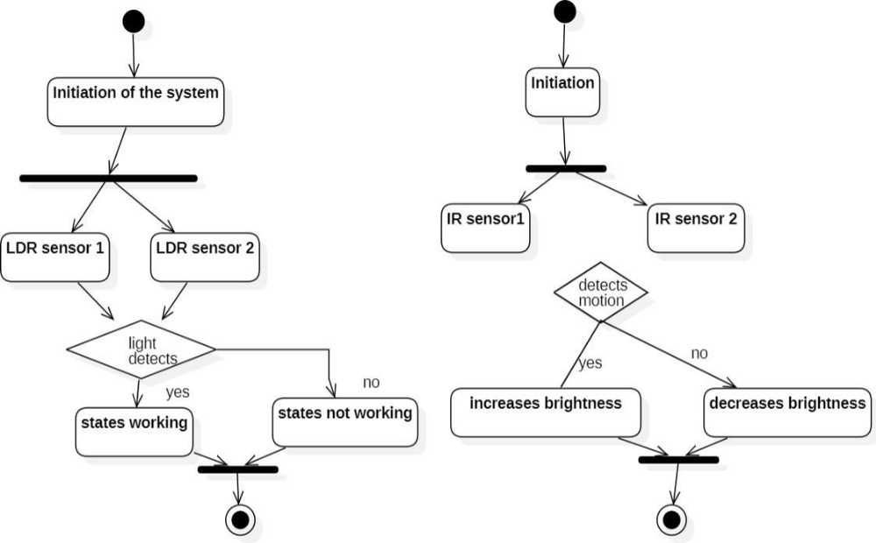

The proposed model for the Smart Street Light System integrates cutting-edge technology to revolutionize urban lighting infrastructure. At its core lies the Arduino Uno microcontroller, serving as the system's central processing unit (CPU). This microcontroller receives inputs from sensors strategically placed within the street light units.Infrared (IR) sensors detect the presence of pedestrians or vehicles, triggering events upon motion detection. These events prompt the Arduino Uno to initiate brightness adjustments in nearby street lights, ensuring adequate illumination only when necessary. Additionally, Light Dependent Resistor (LDR) sensors measure ambient light levels, allowing the system to adapt brightness levels dynamically based on environmental conditions.
To facilitate seamless communication and data transmission, the system employs the MQTT protocol. This lightweight communication protocol enables efficient exchange of information between the sensors, microcontroller, and the central management system.The actuation module controls the LED lights within the street light units, executing brightness adjustments based on commands received from the Arduino Uno. This dynamic brightness adjustment mechanism optimizes energy consumption, reducing operational costs and environmental impact.The central management system serves as the nerve center of the Smart Street Light System, collecting, processing, and analyzing data from all street light units. It provides administrators with real-time insights into system performance, facilitates proactive maintenance by detecting faults, and offers a user-friendly dashboard for monitoring and control.Through a pilot phase followed by full-scale deployment, the proposed model aims to demonstrate the efficacy of IoT-driven street lighting solutions. By integrating advanced sensors, microcontrollers, communication protocols, and centralized management systems, this model promises to usher in a new era of energy-efficient, cost-effective, and environmentally sustainable urban lighting infrastructure.

IV. CIRCUIT DIAGRAM
The circuit diagram explains the connections made with the hardware components and the board. The Arduino uno is connected with the Sensors, LDR and transistor an is given connection with the rails and the other input/output pins are connected to digital as per the requirements.
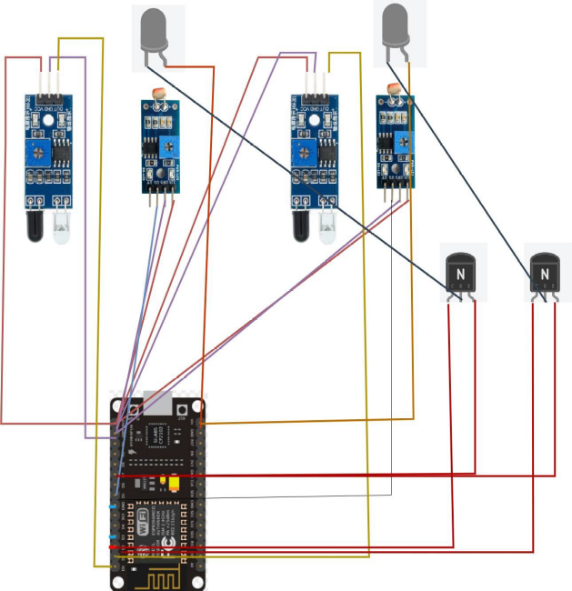
Figure 4.1 Circuit diagram

V MODULE DESCRIPTION
Arduino Uno
This is microcontroller setup for the car parking system which acts as the CPU of the whole system. This takes inputs from the Sensors and triggers the actuators. The Arduino Uno microcontroller serves as the central processing unit (CPU) of the Smart Street Light System, analogous to its role in the car parking system. As the brain of the entire system, it orchestrates the operation by receiving inputs from various sensors and triggering actions through connected actuators. In the context of smart street lighting, the Arduino Uno interprets data from sensors like the IR sensor and the LDR sensor to dynamically adjust the brightness of the LED lights. This adaptability ensures energy efficiency by providing illumination only when necessary, ultimately reducing operational costs and environmental impact.
IR - Sensor
This sensor is used to trigger an event at the time of car’s entry or exit and sends the information to the controller. The IR sensor, commonly used in both car parking systems and smart street light systems, plays a crucial role in detecting the presence of objects, whether it be a vehicle in a parking spot or a pedestrian passing by a street light. When a car enters or exits a parking spot, the IR sensor triggers an event, sending the relevant information to the controller. Similarly, in the case of smart street lights, the IR sensor detects motion and signals the Arduino Uno to adjust the brightness of nearby lights accordingly.
LDR
LDR sensors in smart street light systems detect ambient light levels, enabling automatic adjustment of brightness for energy efficiency and adaptability to environmental changes. LDR sensors are integral to the functionality of smart street light systems. These sensors measure ambient light levels, providing crucial data for the automatic adjustment of brightness levels. By detecting changes in environmental lighting conditions, the system can adapt in real-time, ensuring optimal illumination while conserving energy. This adaptive feature enhances the system's efficiency and responsiveness to environmental changes, making it well-suited for various urban settings.
MQTT
MQTT is used for data transmission, as it is easy to implement and communicate IoT data efficiently. MQTT (Message Queuing Telemetry Transport) serves as the communication protocol for transmitting data within the IoT network efficiently. With its lightweight and scalable nature, MQTT facilitates seamless communication between sensors, the Arduino Uno microcontroller, and other components of the system. By leveraging MQTT, the Smart Street Light System can exchange information swiftly and reliably, enabling swift responsiveness to real-time events and optimizing overall system performance.
Adafruit
In this project, we leverage Adafruit technology to enhance the functionality and efficiency of the Smart Street Light System. Adafruit offers a wide range of high-quality components and modules, including microcontrollers, sensors, and communication devices, that seamlessly integrate with our system architecture. By utilizing Adafruit products, we ensure reliability, compatibility, and ease of implementation, allowing for smoother development and deployment processes. Additionally, Adafruit's robust support community and extensive documentation provide valuable resources for troubleshooting and optimization. Overall, Adafruit technology enhances the performance and scalability of our Smart Street Light System, contributing to its success in urban environments.
VI. RESULT
The implementation of the Smart Street Light System with Arduino Uno, IR sensors, LDR sensors, and MQTT communication protocol offers a transformative solution to urban lighting challenges. Through dynamic brightness adjustments and fault detection mechanisms, this system optimizes energy usage, enhances safety, and streamlines maintenance processes.In practice, the implementation of the system begins with the installation of sensors and LED lights across designated urban areas. The Arduino Uno microcontroller is then programmed to receive inputs from the IR sensors, detecting motion indicative of pedestrian or vehicular presence, and the LDR sensors, measuring ambient light levels for adaptive brightness control. Using this data, the Arduino Uno triggers the LED lights to adjust their brightness levels accordingly, ensuring optimal illumination while conserving energy during periods of low activity.Furthermore, the MQTT communication protocol facilitates seamless data transmission between the components of the system, enabling efficient communication within the IoT network. This allows for real-time monitoring of street light status and the detection of any faults or anomalies. In the event of a fault, such as a malfunctioning LED light or communication issue, alerts are promptly sent to the central management system for immediate attention and maintenance scheduling.The implementation of the Smart Street Light System yields tangible results in terms of energy savings, cost reduction, and improved safety. By dynamically adjusting brightness levels based on real-time activity and ambient light conditions, the system significantly reduces energy consumption, leading to lower operational costs and a smaller carbon footprint. Additionally, the proactive fault detection mechanisms minimize downtime and maintenance expenses, ensuring continuous and reliable street lighting for urban residents.Overall, the implementation of the Smart Street Light System represents a paradigm shift in urban lighting infrastructure, offering a scalable and sustainable solution that enhances the efficiency, safety, and resilience of modern cities.

VII. CONCLUSION
In conclusion, the incorporation of IoT-enabled smart street light system has led to significant strides in urban lighting infrastructure by achieving its goals of enhancing sustainability, safety, and efficiency. The system effectively decreases energy consumption and ensures ideal illumination levels based on real-time requirements through combining presence detection and dynamic brightness management. Future enhancements to the Internet of Things' smart street light system will include including solar power along with additional renewable energy sources, using innovative sensor technologies for precise identification and environmental monitoring, implementing artificial intelligence into practice in predictive maintenance algorithms, and developing dynamic adaptive lighting algorithms. Efficiency, safety, and sustainability can also be further improved through cooperation with other smart city systems, social platforms, environmental impact monitoring, emergency response integration, energy storage solutions, and edge computing capabilities. The implementation of the Smart Street Light System with Arduino Uno, IR sensors, LDR sensors, and MQTT communication protocol offers a transformative solution to urban lighting challenges. Through dynamic brightness adjustments and fault detection mechanisms, this system optimizes energy usage, enhances safety, and streamlines maintenance processes. In conclusion, the Smart Street Light System represents a significant advancement in urban lighting infrastructure, leveraging IoT technology to optimize energy usage, enhance safety, and streamline maintenance processes. Through the integration of Arduino Uno microcontrollers, IR sensors, LDR sensors, and MQTT communication protocol, this system offers a dynamic and adaptive solution to the challenges posed by traditional street lighting systems.By dynamically adjusting brightness levels based on real-time activity and ambient light conditions, the Smart Street Light System achieves substantial energy savings while ensuring optimal illumination for pedestrians and vehicles. This energy efficiency not only reduces operational costs but also contributes to environmental sustainability by lowering carbon emissions and resource consumption. Moreover, the system's fault detection mechanisms enable proactive maintenance, minimizing downtime and ensuring continuous operation of street lights. By promptly identifying and addressing issues such as bulb failures or communication problems, the system enhances reliability and resilience, ultimately improving the quality of life for urban residents. The implementation of the Smart Street Light System has demonstrated tangible benefits in pilot studies, with promising results in terms of energy savings, cost reduction, and safety enhancement. These benefits are expected to scale with broader deployment across urban areas, offering cities a scalable and sustainable solution to their lighting needs.Looking ahead, the Smart Street Light System has the potential to further evolve and integrate with other smart city initiatives, such as traffic management systems and environmental monitoring networks. By leveraging data-driven insights and advanced technologies, cities can continue to enhance efficiency, sustainability, and livability for their residents.In summary, the Smart Street Light System represents a transformative solution that not only addresses the shortcomings of traditional street lighting but also paves the way for smarter, more resilient, and more sustainable urban environments. As cities continue to grow and evolve, innovative solutions like the Smart Street Light System will play a crucial role in shaping the cities of the future.

REFERENCE

[1] Khelil, A., Klug, R., & Ibrahim, N. (2017). An IoT-based Intelligent Street Lighting System. In 2017 13th IEEE International Conference on Intelligent Computer Communication and Processing (ICCP) (pp.
109-116). IEEE.
[2] Suryakalavathi, S., & Rajeswari, K. (2020). Smart Street Lighting Control and Monitoring System for Efficient Power Saving. In 2020 International Conference on Computing, Communication, and Automation (ICCCA) (pp. 1-6). IEEE.
[3] Nafisi, Z. M., Ibrahimy, M. I., & Ahmad, R. B. (2018). A Review on Smart Street Lighting System: Control and Optimization. In 2018 International Conference on Advances in Electrical, Electronic and Systems Engineering (ICAEES) (pp. 25-30). IEEE.
[4] Yaqoob, M., Salah, A., & Ahmed, A. (2017). Smart Street Lighting: A Literature Review. In 2017 3rd International Conference on Control, Automation and Robotics (ICCAR) (pp. 571-575). IEEE.
[5] Ahmed, S. H., & Islam, S. N. (2018). Smart Street Lighting Systems: Challenges and Opportunities. In 2018 International Conference on Electrical, Computer and Communication Engineering (ECCE) (pp. 1-6). IEEE.
[6] Smart grid ; Integrating Renewable, Distributed and Efficient Energy, Ferritoon P.Sioshansi Acadamic Press, 2011, 9780123864529.

